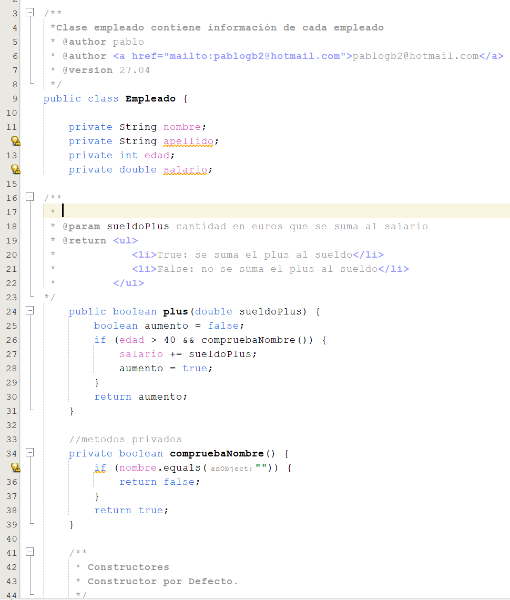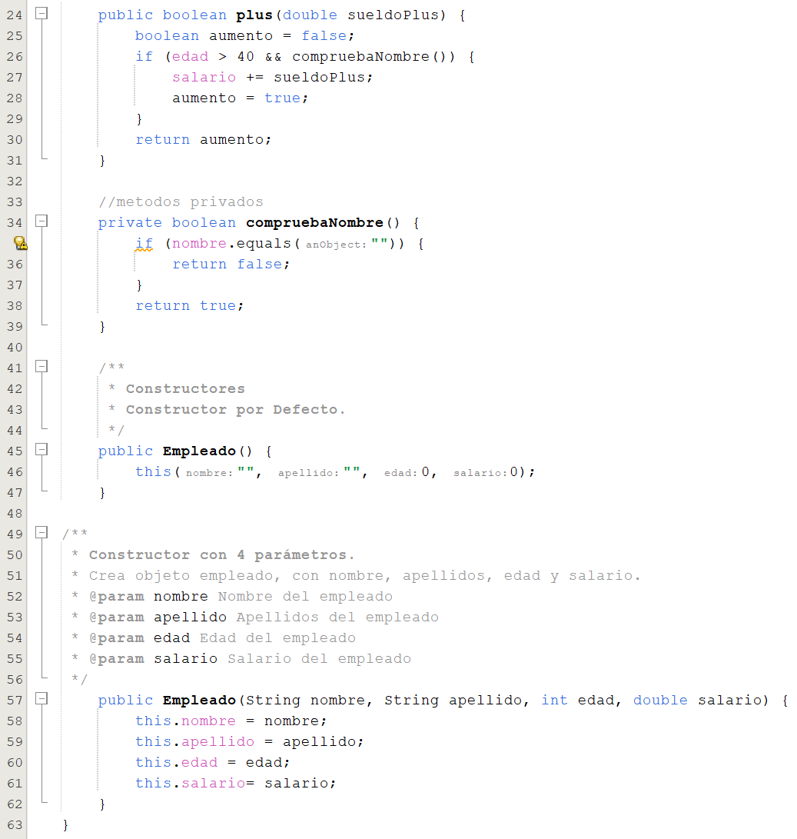

[pabloginerbarriosjavadoc.netlify.app](https://pabloginerbarriosjavadoc.netlify.app/)

<https://github.com/Argueth/06_EMPLEADO_JAVADOC>